7.70: a) In this problem, use of algebra avoids the intermediate calculation of the spring constant k. If the original height is h and the maximum compression of the spring is d, then 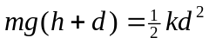. The speed needed is when the spring is compressed , and from conservation of energy, 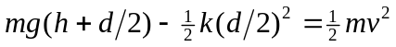. Substituting for k in terms of 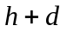,
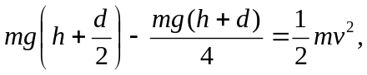
which simplifies to
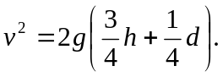
Insertion of numerical values gives 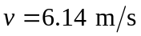. b) If the spring is compressed a distance x, 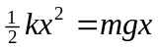, or 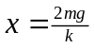. Using the expression from part (a) that gives k in terms of h and d,
